Declaration

I thus declare that the project work I completed for the requirements of the Bachelor's Second Semester degree is titled "Tally," and it covers a general concept of accounting. It was completed entirely by myself. The results included in the report have not been submitted for the award of a BCA degree to any other institution or institute.

Name: Salin Limbu

BCA (Second Semester)

Roll no :25

ACKNOWLEDGEMENT

This lab report is specifically assigned by the academic institution to BCA 2nd semester students for partial course fulfilment and is developed for the systematic and accurate use of accounting software, namely 'Tally'. For the effective completion of this lab report, I am grateful to the many hands who assisted me. I am grateful to my subject teacher, Mr. Rajendra Bista sir, for his direction and continual monitoring, as well as for giving necessary project information and assistance in completing the lab report. Similarly, I am grateful to the institution and faculty administration for providing critical resources and exceptional support in this study. Finally, I'd like to offer my heartfelt appreciation to the TU board.

**History Of Accounting**

**INTRODUCTION**

Accounting can be defined as a process of reporting, recording, interpreting and summarising economic data. Accounting is the management information system of any organization and is concerned with providing necessary information to the management, i.e. it is a source of information. In the account, every step involves either generation or processing accounting information. It serves as a means as well as an end of providing information to all stakeholders who need information to make a proper decision.

It provides an essential tool for billing customers, keeping track of assets and liabilities (debts), determining profitability, and tracking the flow of cash. The system is largely self-regulated and designed for the users of financial information, who are referred to as stakeholders: business owners, lenders, employees, managers, customers, and others.

**HISTORY**

The history of accounting or accountancy can be traced to ancient civilizations. The early development of accounting dates to ancient Mesopotamia, and is closely related to developments in writing, counting and money and early auditing systems by the ancient Egyptians and Babylonians. By the time of the Roman Empire, the government had access to detailed financial information.

In India, Chanakya wrote a manuscript similar to a financial management book, during the period of the Mauryan Empire. His book Arthashastra contains few detailed aspects of maintaining books of accounts for a sovereign state.

The Italian Luca Pacioli, recognized as The Father of accounting and bookkeeping was the first person to publish a work on double-entry bookkeeping, and introduced the field in Italy.

The modern profession of the chartered accountant originated in Scotland in the nineteenth century. Accountants often belonged to the same associations as solicitors, who often offered accounting services to their clients. Early modern accounting had similarities to today's forensic accounting. Accounting began to transition into an organized profession in the nineteenth century,[9] with local professional bodies in England merging to form the Institute of Chartered Accountants in England and Wales in 1880.

**Accounting and accounting software**

**Definition**

Accounting can be defined as a process of reporting, recording, interpreting and summarising economic data. Accounting is the management information system of any organization and is concerned with providing necessary information to the management, i.e. it is a source of information. In the account, every step involves either generation or processing accounting information. It serves as a means as well as an end of providing information to all stakeholders who need information to make a proper decision.

It provides an essential tool for billing customers, keeping track of assets and liabilities (debts), determining profitability, and tracking the flow of cash. The system is largely self-regulated and designed for the users of financial information, who are referred to as stakeholders: business owners, lenders, employees, managers, customers, and others

Upgrading the traditional version of bookkeeping, account software helps you automate your finance management process by cutting down the time of repetitive tasks of payable amounts, billing and invoicing, and reconciliation..

**Importance of accounting software**

1. Expense tracking
2. Bank reconciliation
3. Timesheets and project management
4. Inventory management
5. Tax compliance
6. Report generation
7. User-Friendliness
8. Analysis and Report
9. Automatic Updates & Scalability
10. Billing and Invoicing & Payment Processing
11. Mobile Usage
12. Security
13. Identify and Prevent Errors

**Introduction to Tally**

Tally is powerful accounting software, which is driven by a technology called concurrent multi-lingual accelerated technology engine. It is easy to use software and is designed to simply complex day to day activities associated in an enterprise.

Tally provides comprehensive solution around accounting principles, inventory and data integrity. Tally also has feature encompassing global business. Tally software comes with easy to use interface thus making it operationally simple.

Tally accounting software provides a solution around inventory management, stock management, invoicing, purchase order management, discounting, stock valuation methodology, etc.

Tally accounting software also comes with drill down options, which can track every detail of transaction. It helps in maintaining simple classification of accounts, general ledger, accounts receivable and payable, bank reconciliation, etc.

1. **Getting started with Tally:**

* Install Tally ERP 9 on your computer.
* Click on the icon and open it.

1. **Creating company in Tally ERP 9:**

* Go to gateway of Tally.
* In company info we can see Create Company.
* Select it, Company creation window will appear.
* At last the message Accept? Yes/No will be displayed.

1. **Creating accounting Ledgers:**

* Go to gateway of Tally.
* Select Account Info and Click on Create.
* Enter name of account and fill other data.

**Voucher Entry**

A voucher is a document that contains details of a financial transaction and is required for recording the same into the books of accounts. For every transaction, you can use the appropriate Tally voucher to enter the details into the ledgers and update the financial position of the company.

**Contra Entry:** Contra entry refers to transactions involving cash and bank account. In other words, any entry which affects both cash and bank accounts is called a contra entry. Contra in Latin means the opposite. It is more popularly known as contra voucher

**Question solved in Tally**

**Creating company in Tally ERP 9:**

* Go to gateway of Tally.

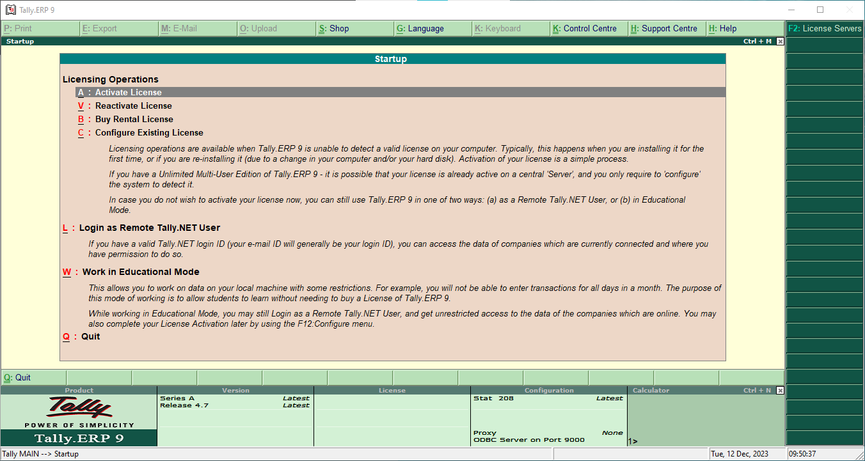

* In company info we can see Create Company.

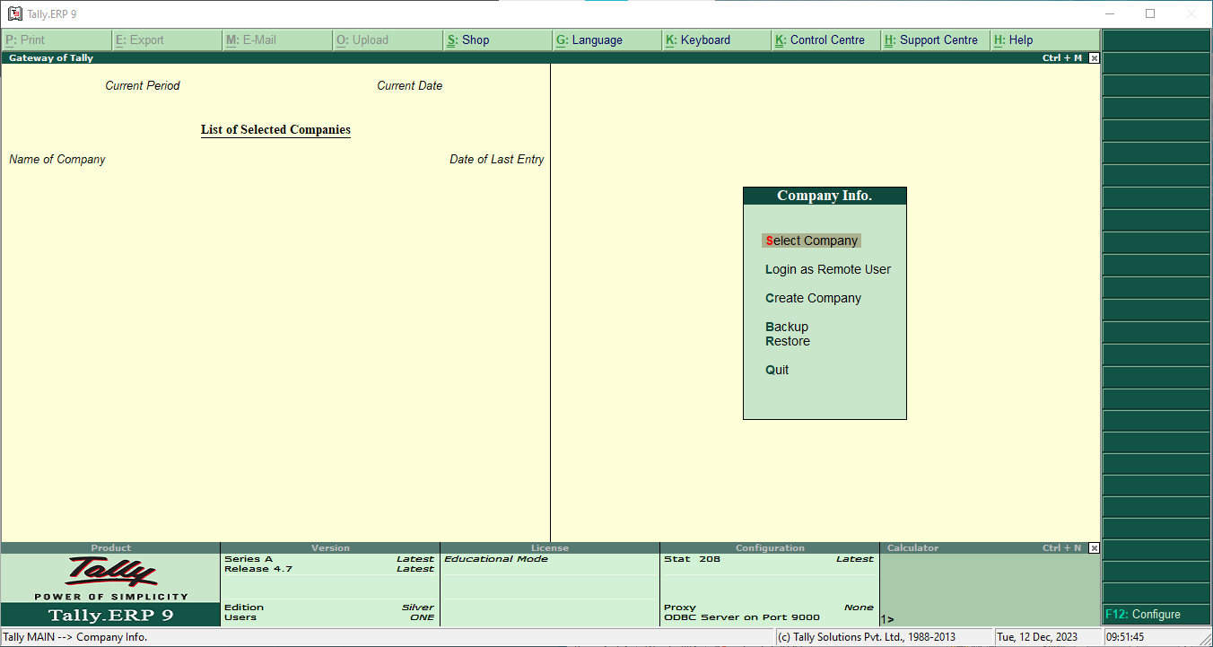

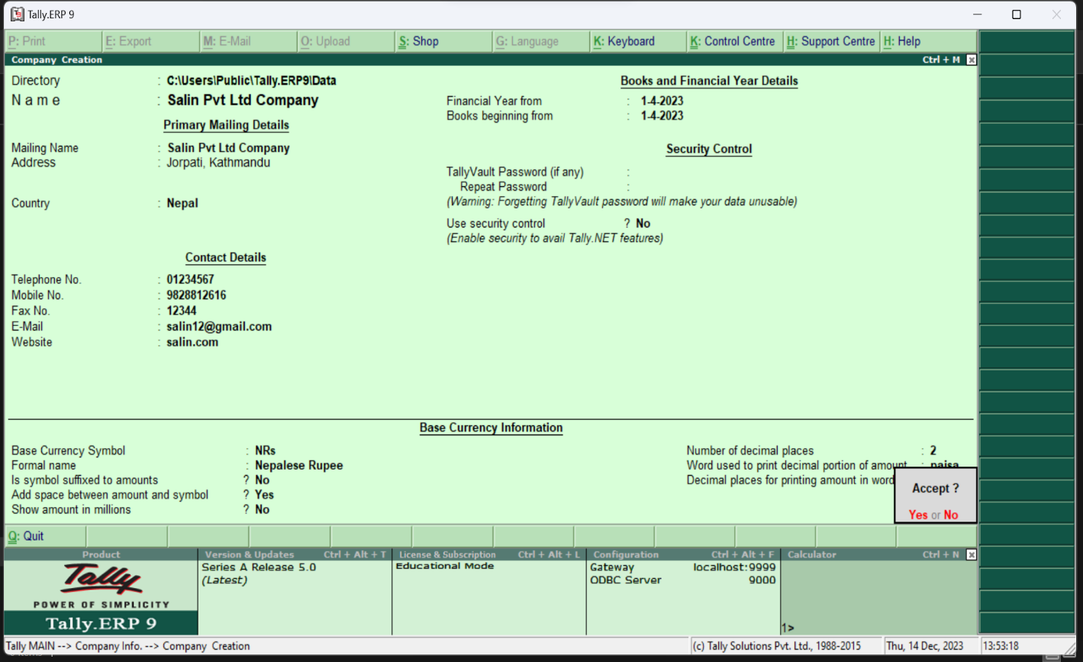

**3. You are given the following transactions:**

a. Started a business with cash Rs. 300,000, Furniture Rs. 200,000.

b. Opened the bank account with Rs. 50,000

c. Cash drew from bank Rs. 10,000

d. Purchased a machinery worth Rs. 100,000

e. Purchased goods on credit Rs. 20,000

f. Sold goods costing Rs. 500,000 on cash for Rs. 5,000

g. Paid wages Rs. 40,000

h. Paid salary Rs. 50,000 and still payable Rs. 20,000

i. Paid rent in advance Rs. 30,000

j. Commission received in advance Rs. 20,000

k. Depreciation on Machinery Rs. 5,000

Required:

a. Journal Entries

b. Cash Account

c. Machinery Account

**Ledger**

**Creation of ledger:**

For Journal, we must first create accounts (ledgers) for it to identify. For this we must follow the following:

1. In the masters section, we must go to Accounts info.
2. In the accounts Info, we go to Ledger.
3. In the single Ledger, go to create.
4. Then we create the necessary ledgers

All the necessary ledgers are created below:

1. **Cash A/c**

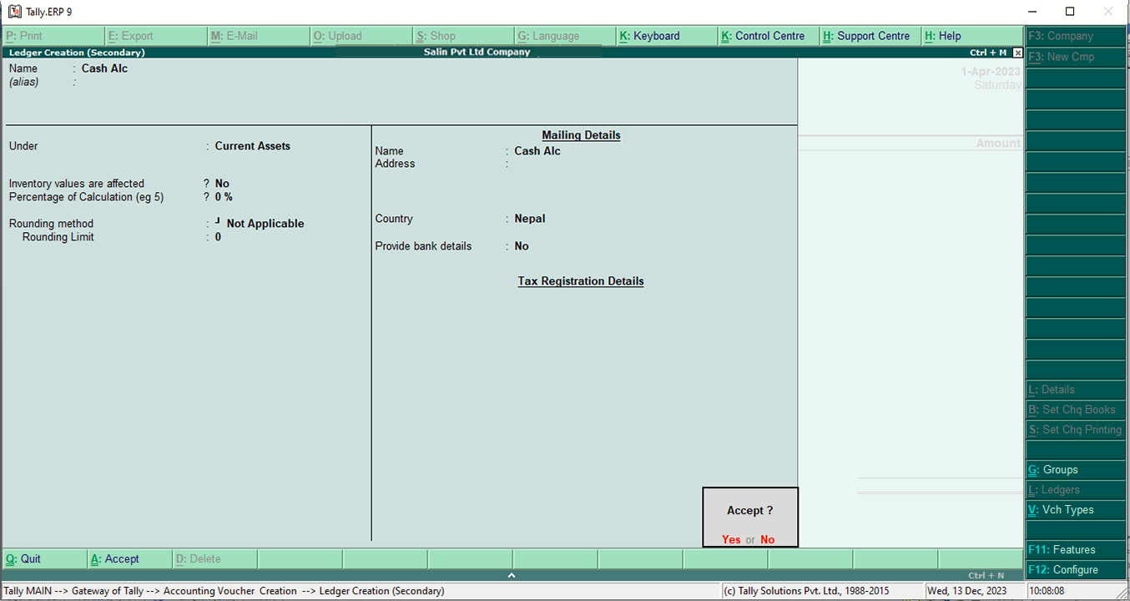

1. **Furniture A/c**

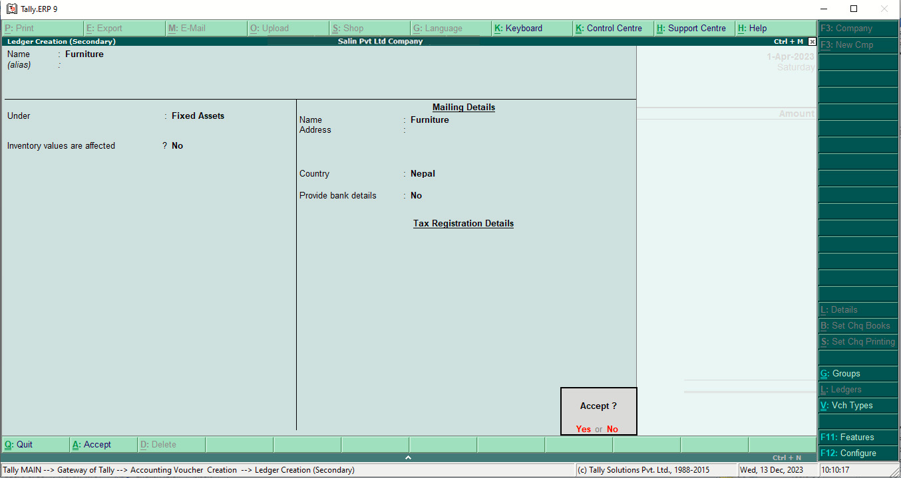

1. **Capital A/c**

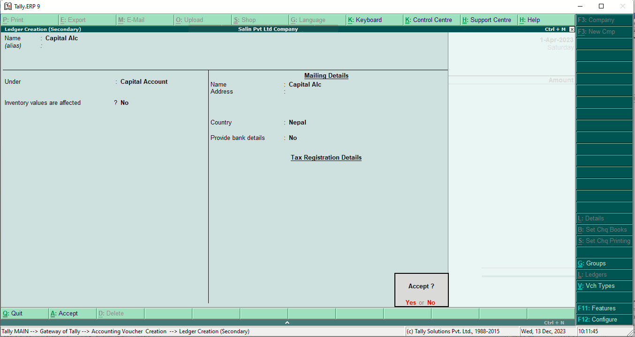

1. **Bank A/c**

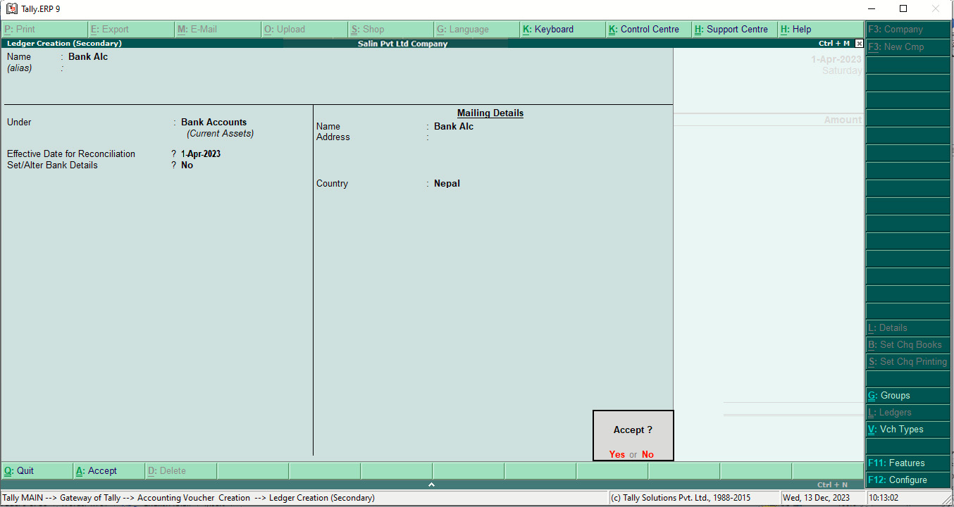

1. **Purchase A/c**

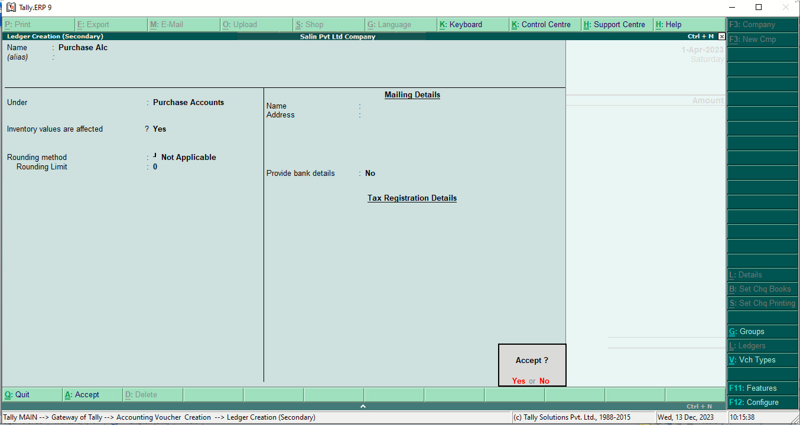

1. **Machinery A/c**

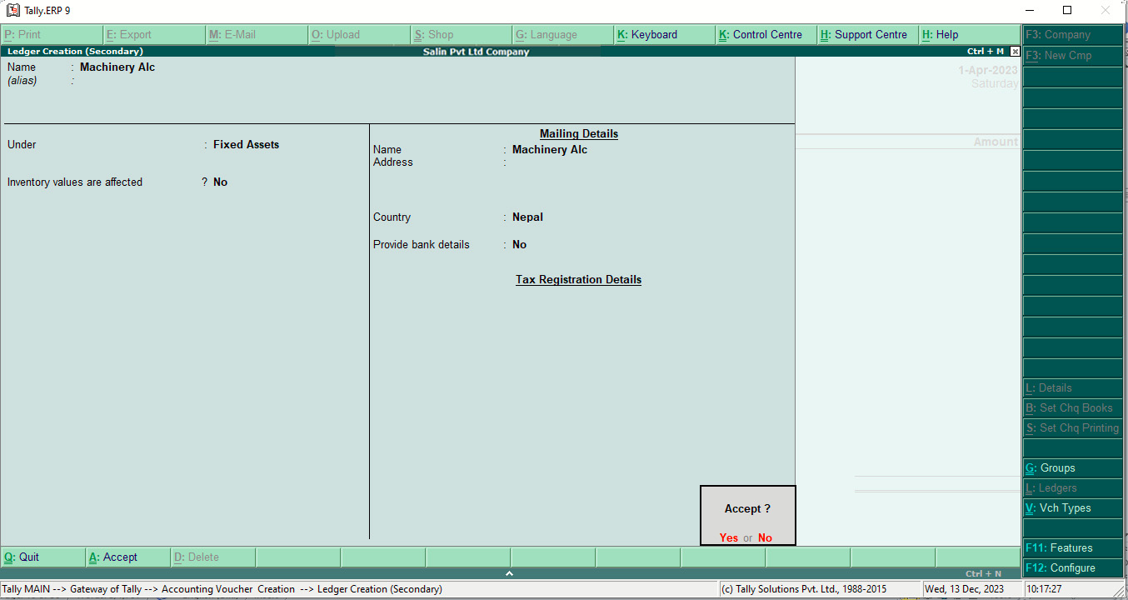

1. **Creditors a/c**

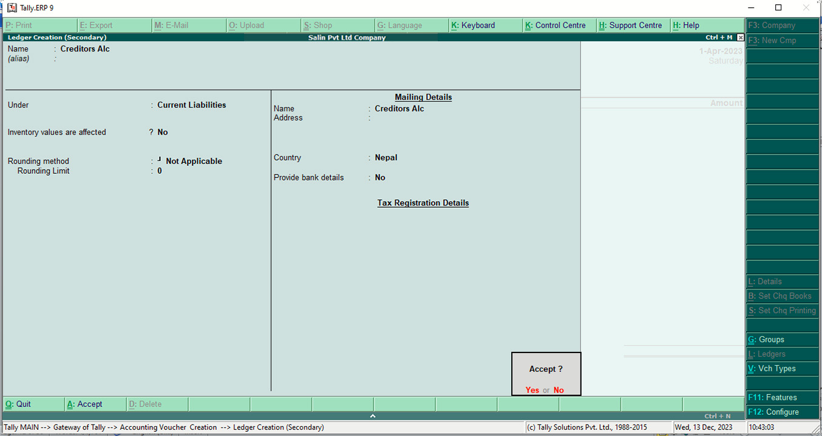

1. **Sales A/c**

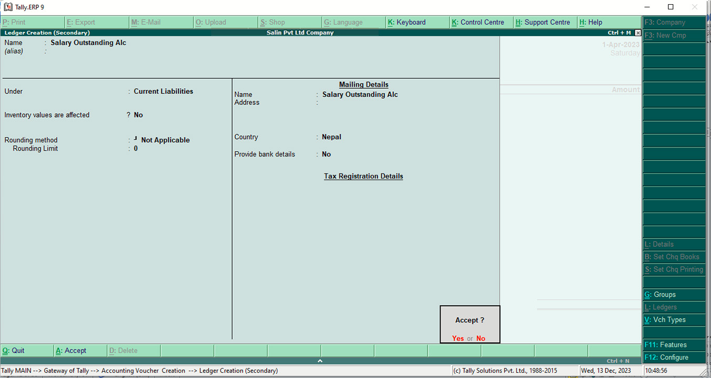

1. **Salary outstanding a/c**



1. **Wages A/c**

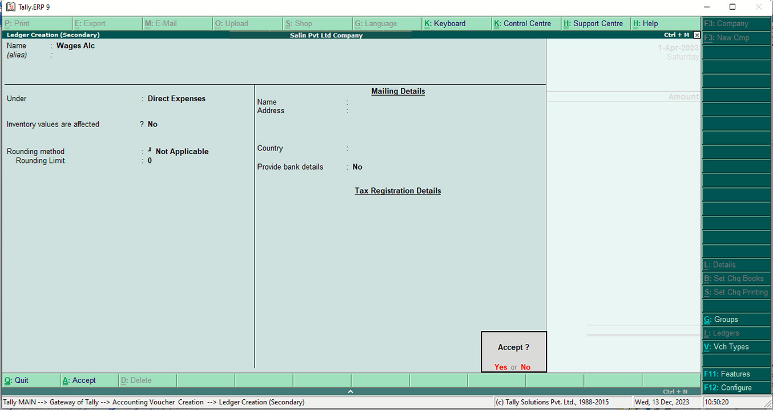

1. **Advance Commission Received A/c**

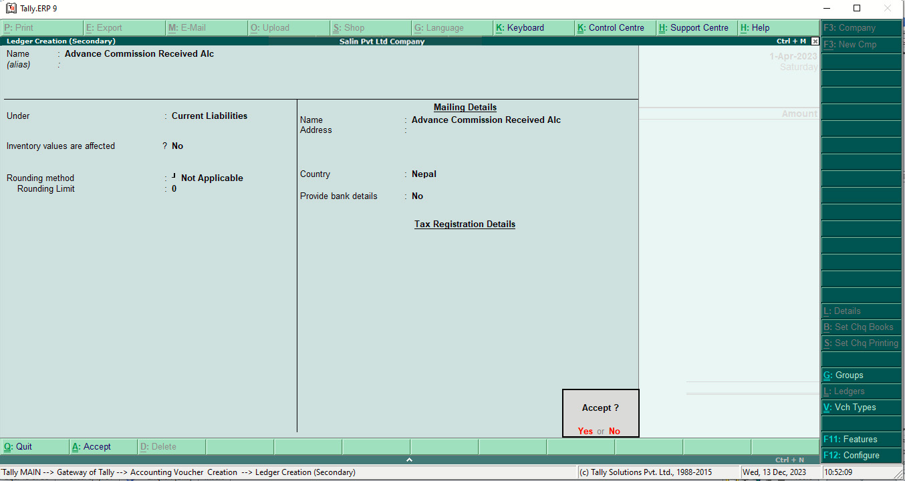

1. **Depreciation on Machinery A/c**

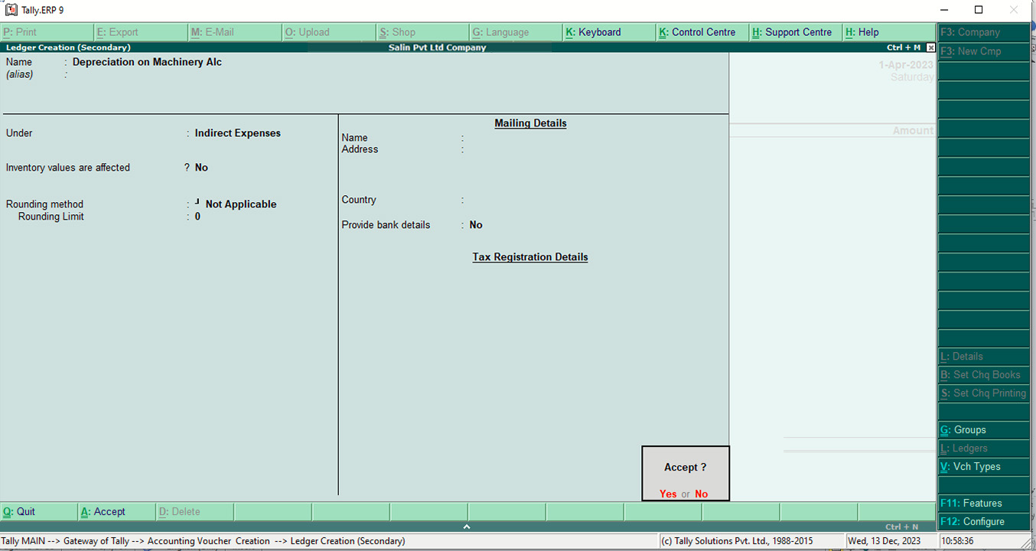

1. **Salary A/c**

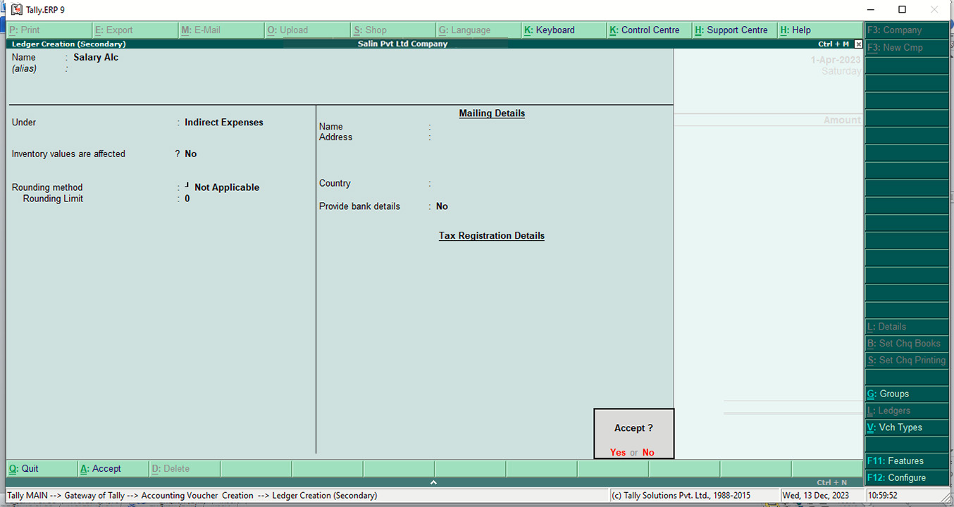

1. **Advance Rent A/c**

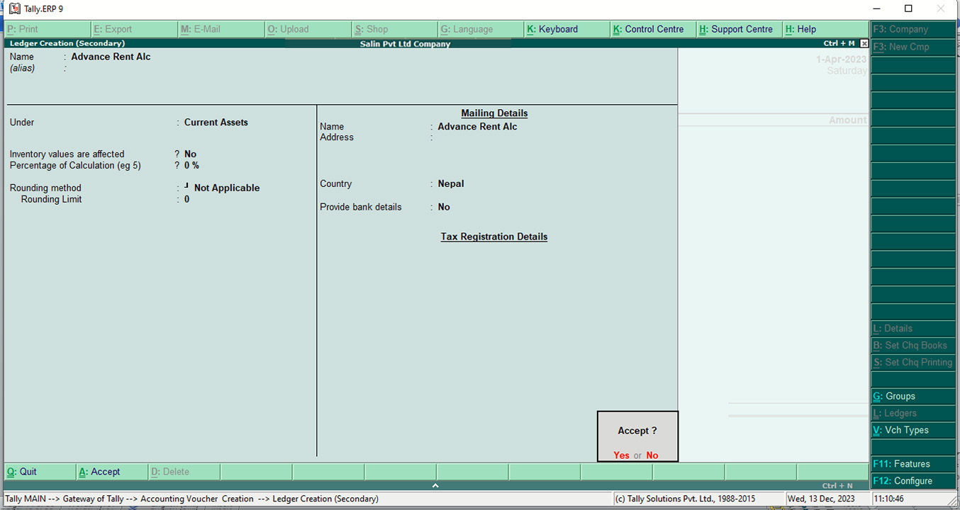

**Posting In Journal**

1. Go to accounting vouchers of the transaction group.
2. Then list all the transactions.

All the transaction is listed below:

1. **Started a business with cash Rs. 300,000, Furniture Rs. 200,000.**

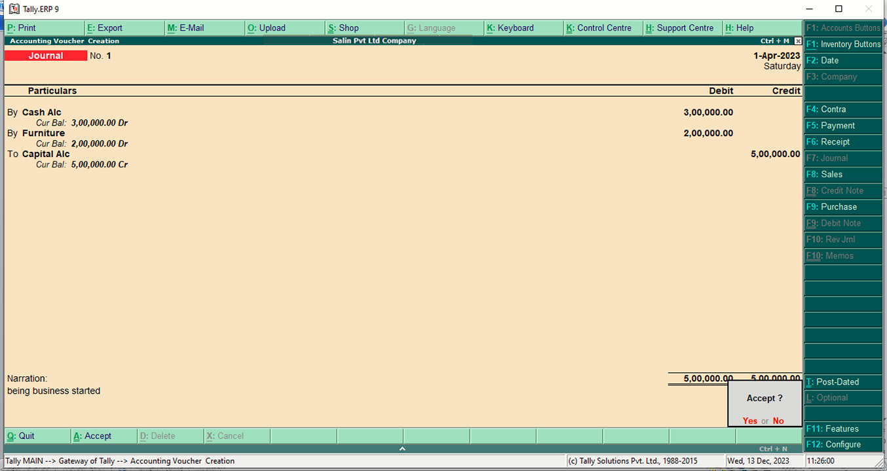

1. **Opened the bank account with Rs. 50,000**

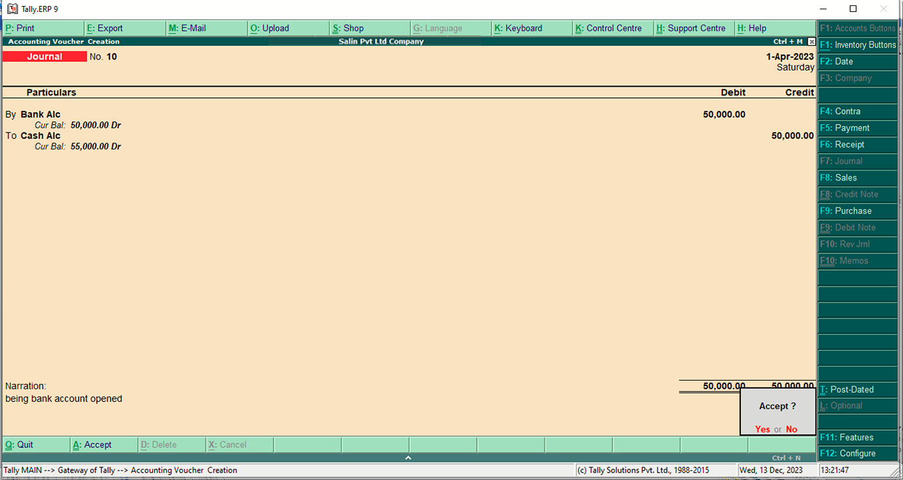

1. **Cash drew from bank Rs. 10,000**

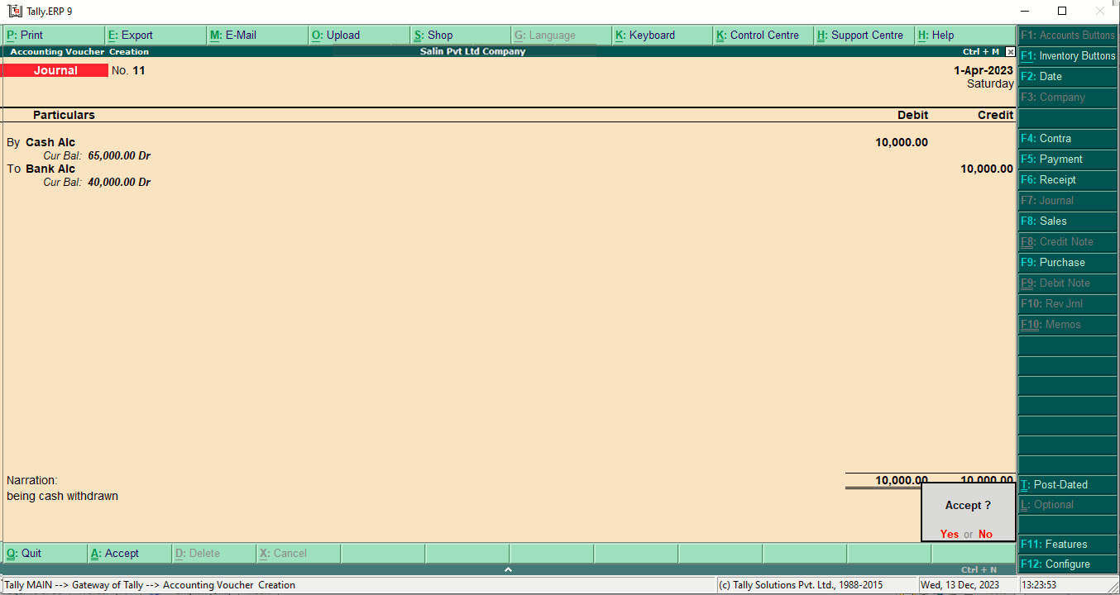

1. **Purchased a machinery worth Rs. 100,000**

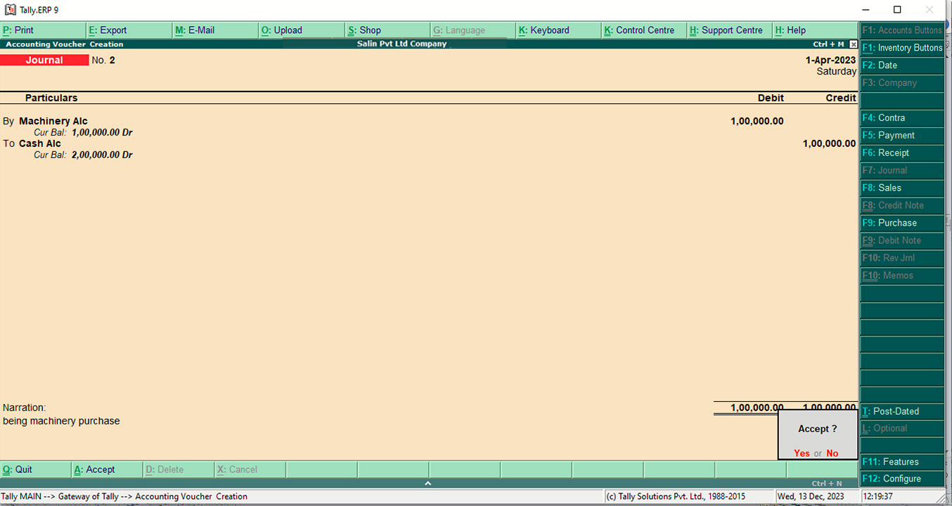

1. **Purchased goods on credit Rs. 20,000**

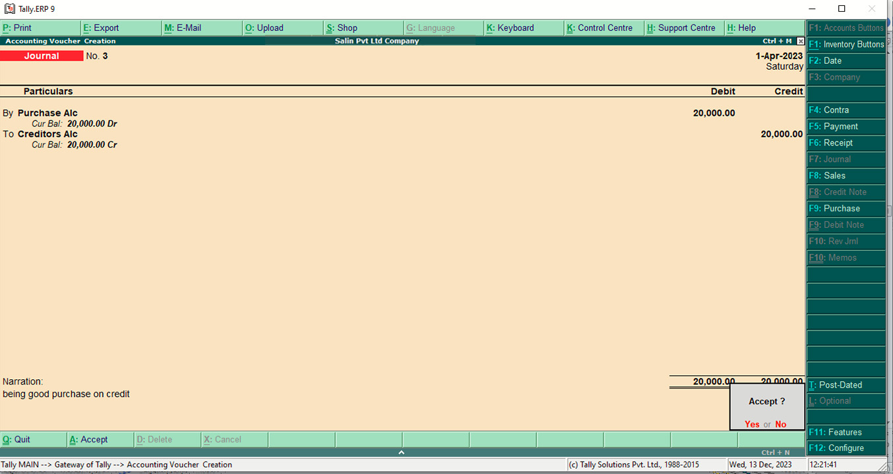

1. **Sold goods costing Rs. 500,000 on cash for Rs. 5,000**

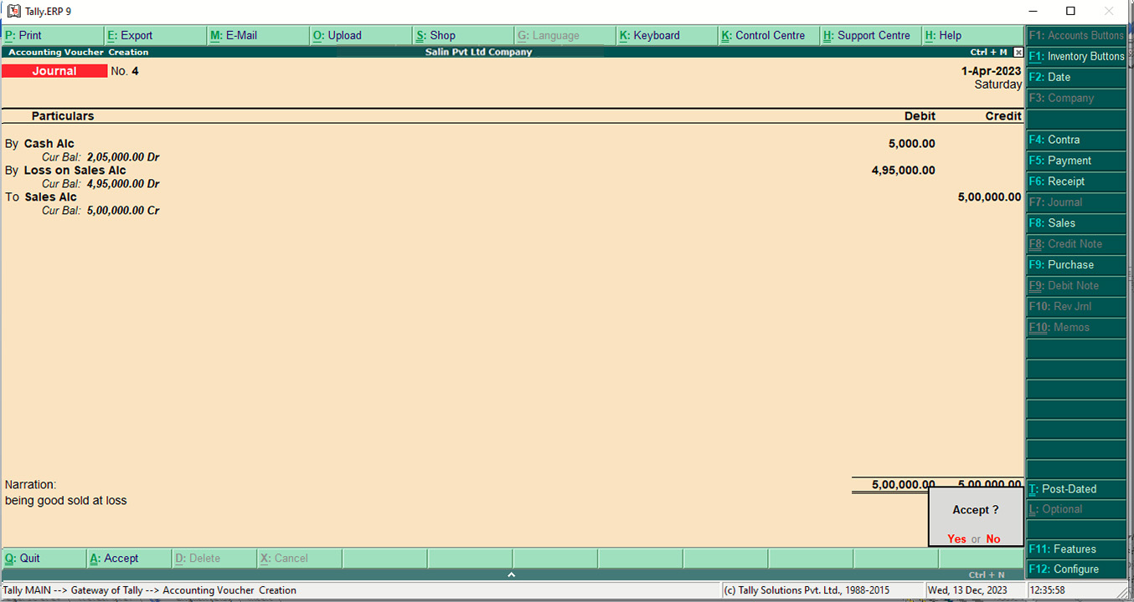

1. **Paid wages Rs. 40,000**

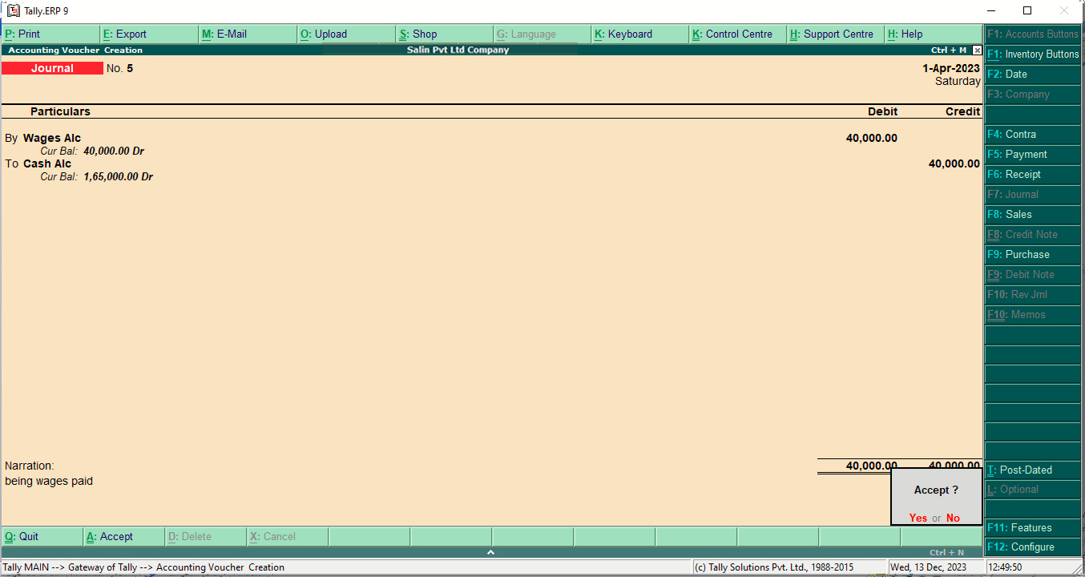

1. **Paid salary Rs. 50,000 and still payable Rs. 20,000**

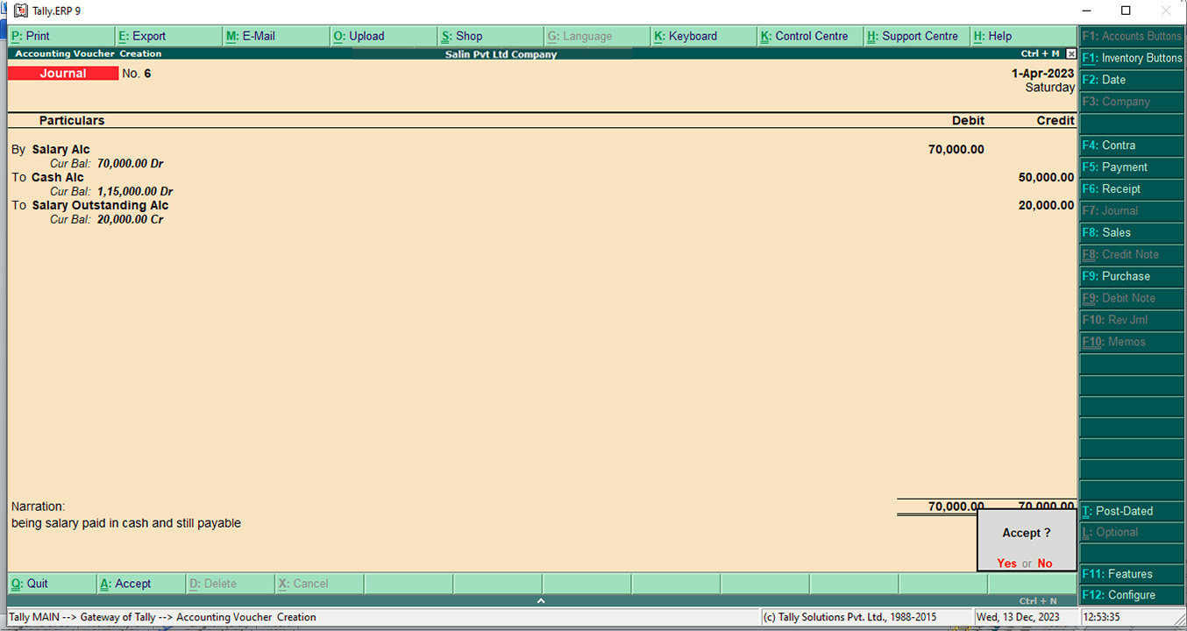

1. **Paid rent in advance Rs. 30,000**

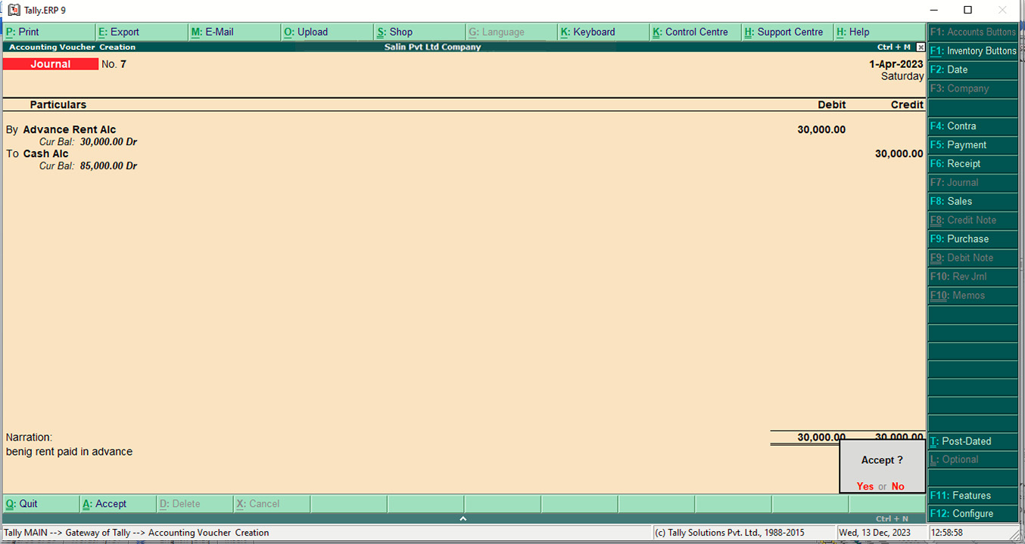

1. **Commission received in advance Rs. 20,000**

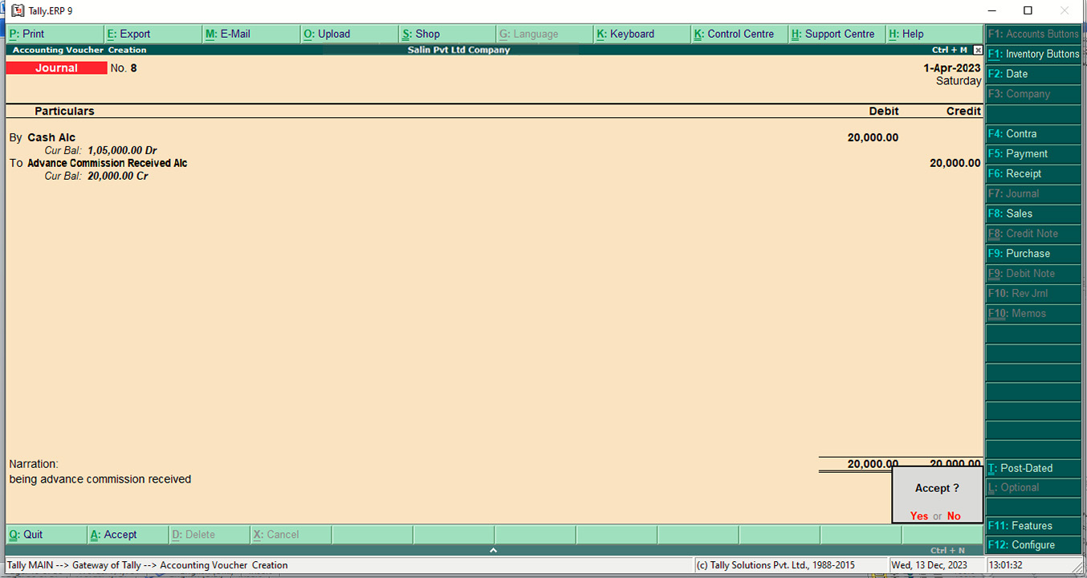

1. **Depreciation on Machinery Rs. 5,000**

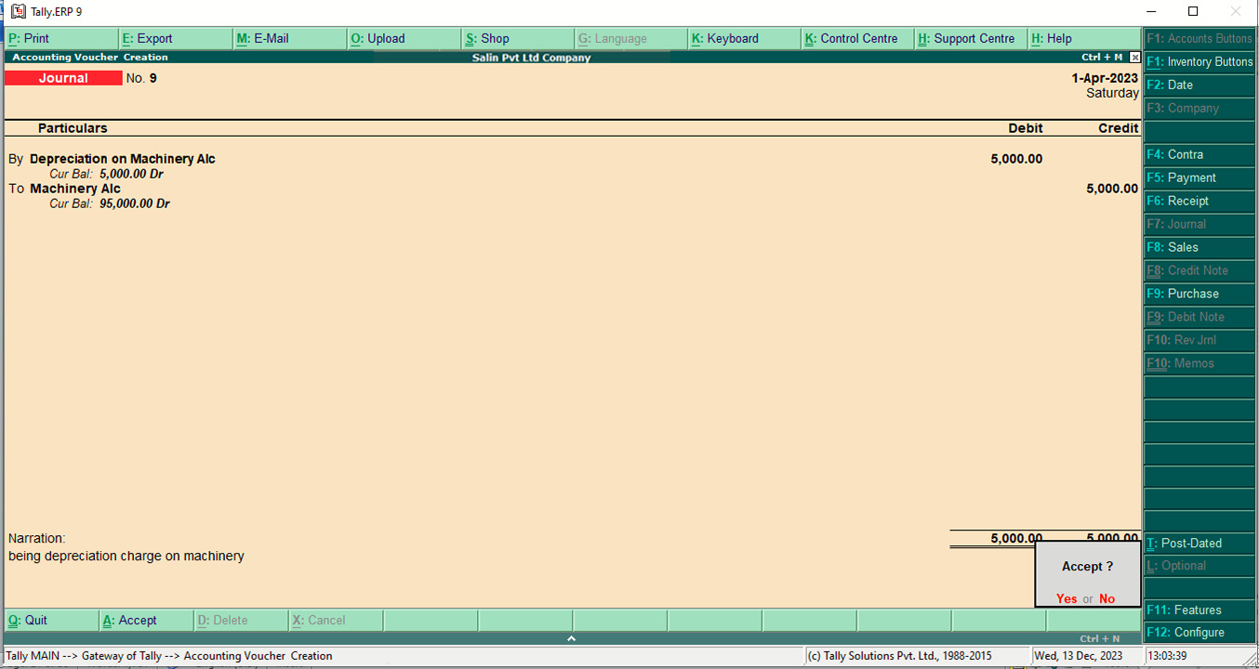

1. **All Journal Entries**

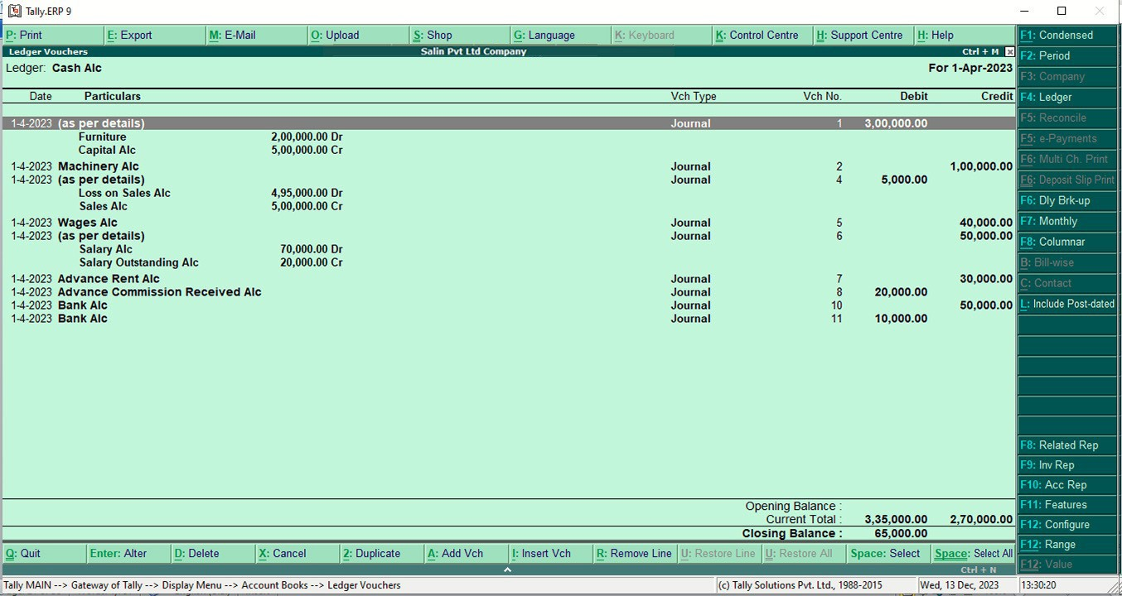

1. **Cash A/c**



1. **Machinery A/c**

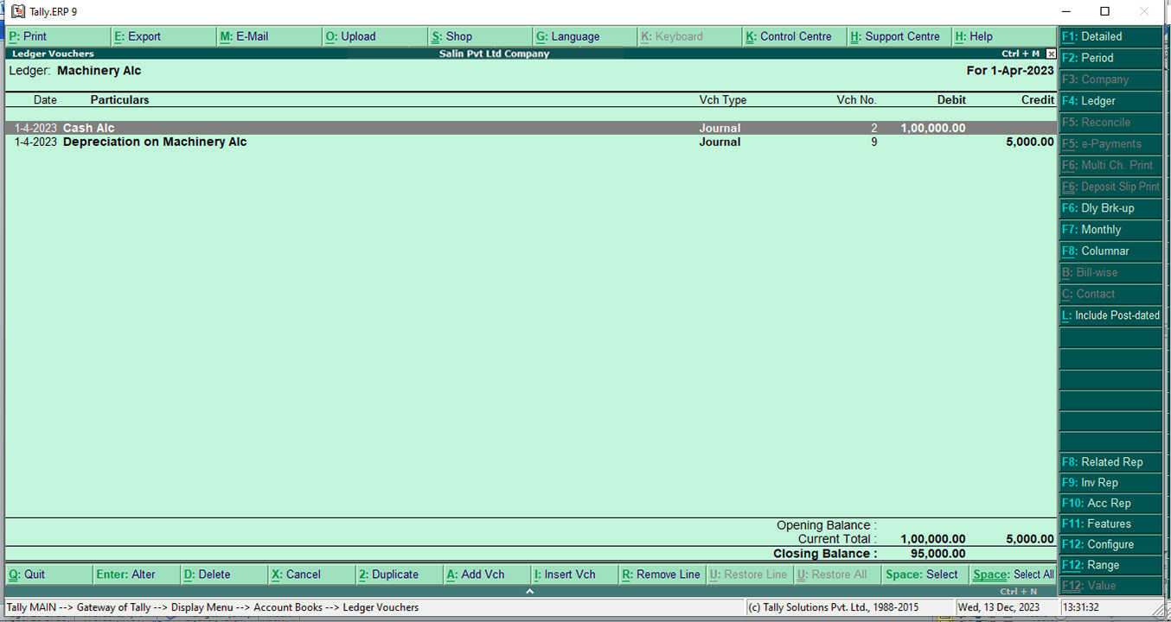

1. **Following transactions are given:**

Feb 1: Purchased from Pashupati & co.

100 Economics books @ Rs. 300 each.

50 Accountancy books @ Rs. 700 each.

200 English Books @ Rs. 300

50 Pressure cookers @ Rs. 500 each

100 table fans @ Rs. 1,000 each

Feb 3: Purchased on cash.

20 tables @ Rs. 1,000 each

20 Dell @ Rs. 30,000 each

2 Samsung @ Rs. 120,000 each.

5 Lenovo @ Rs. 100,000 each

Feb 7: Sold laptops to Shrestha electronics, on credit.

15 Dell @ Rs. 35,000 each

4 Lenovo @ Rs. 90,000 each.

Feb 9: Sold on cash

40 Economics books @ Rs. 325 each

15 Pressure cookers @ Rs. 550 each

12 tables @ Rs. 1,275 each

45 Accountancy books @ Rs. 720 each

**Required:**

a. Stock Query b. Various Inventory Reports

**Stock Items**

1. **Units**

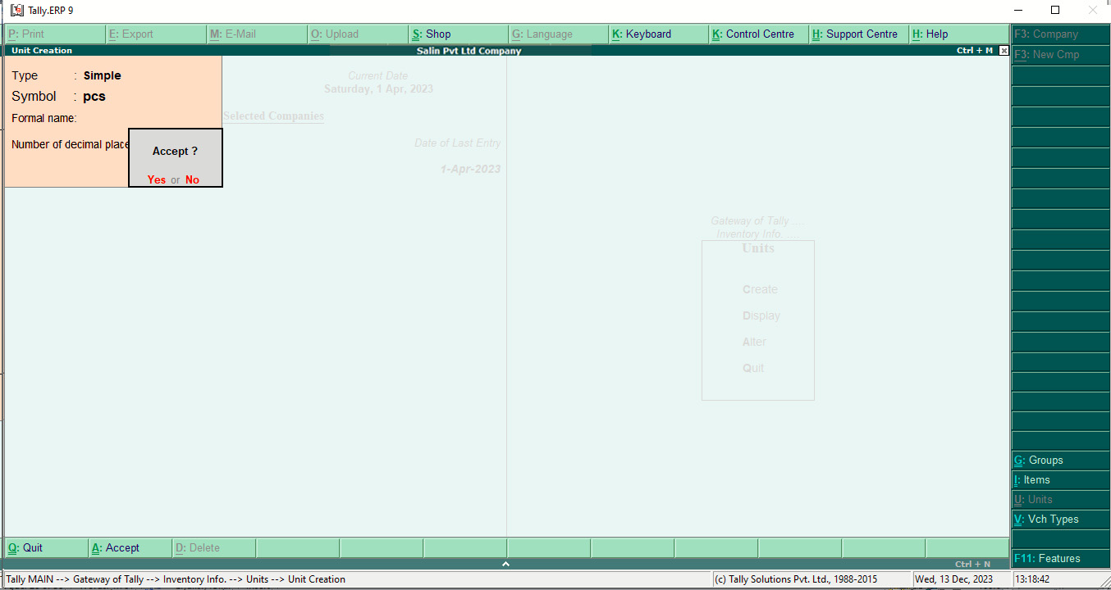

1. **Economics books**

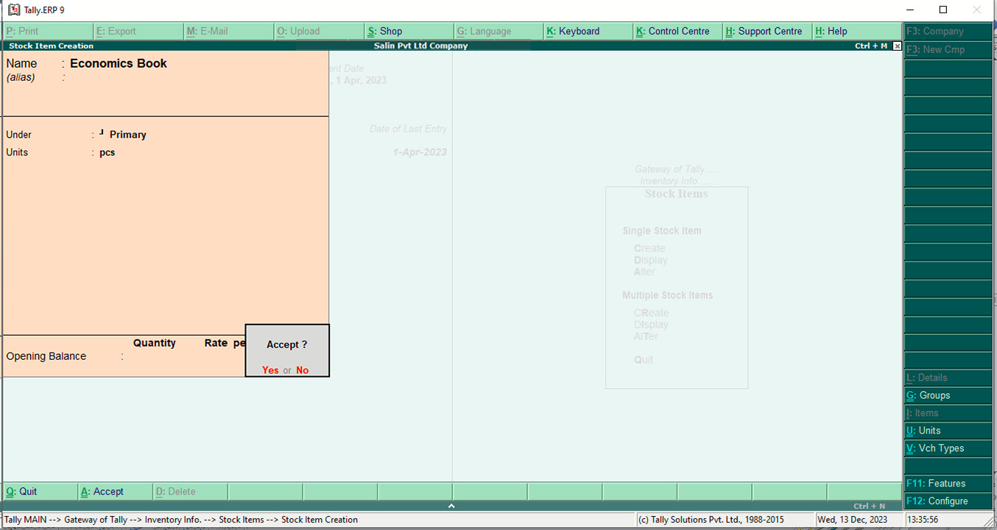

1. **Accountancy books**

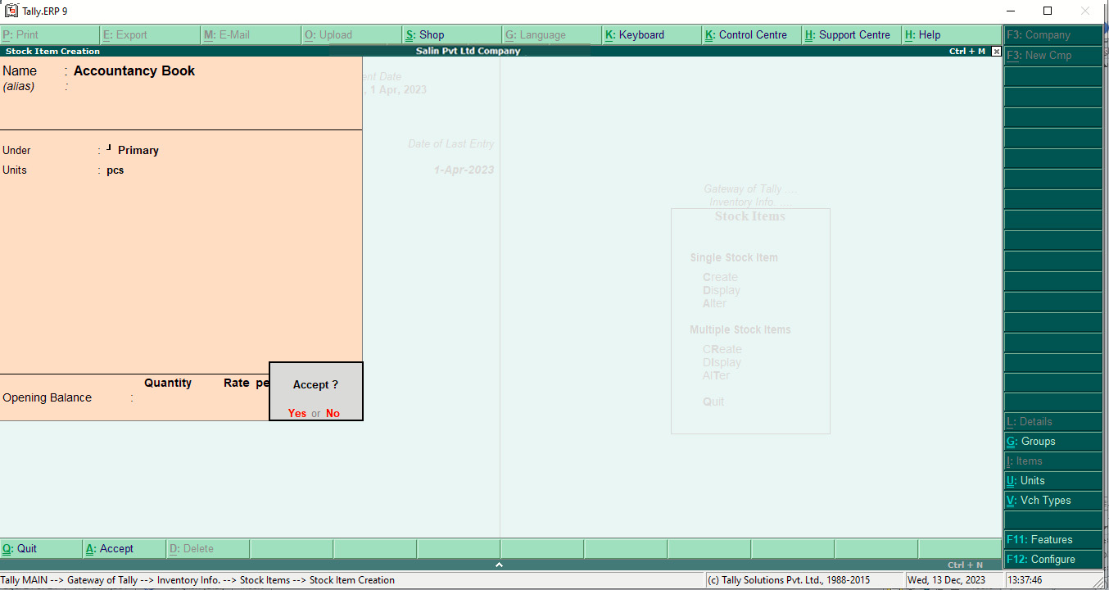

1. **English Books**

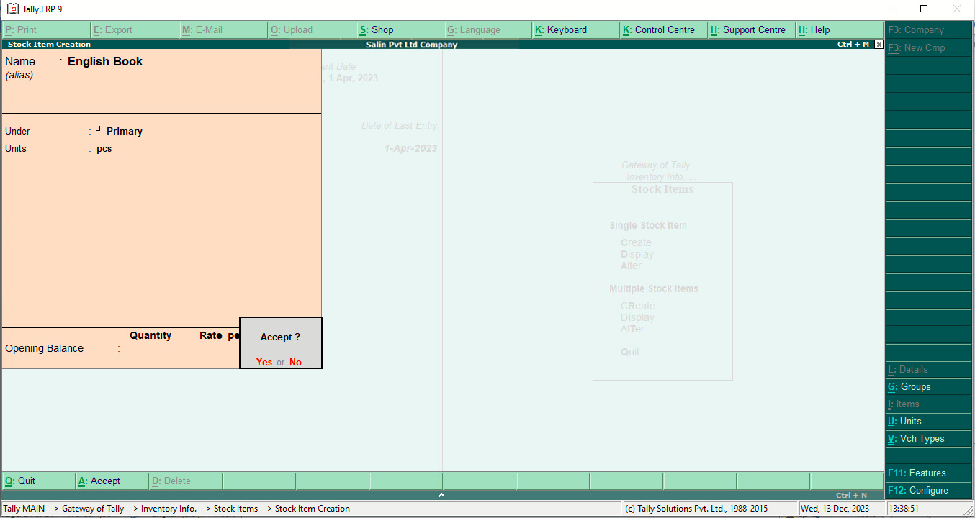

1. **Pressure cooker**

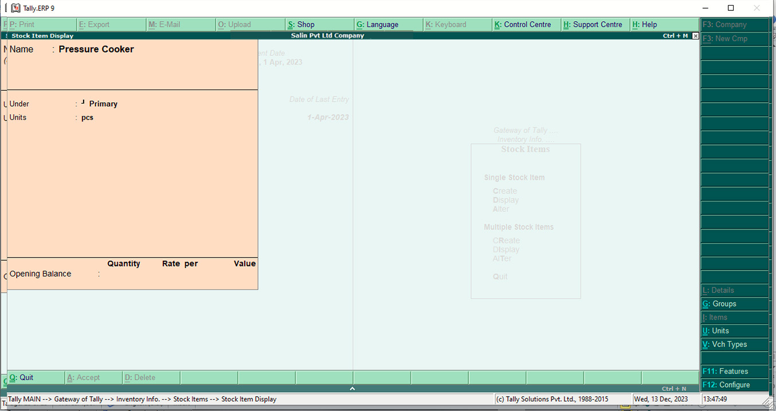

1. **table fans**

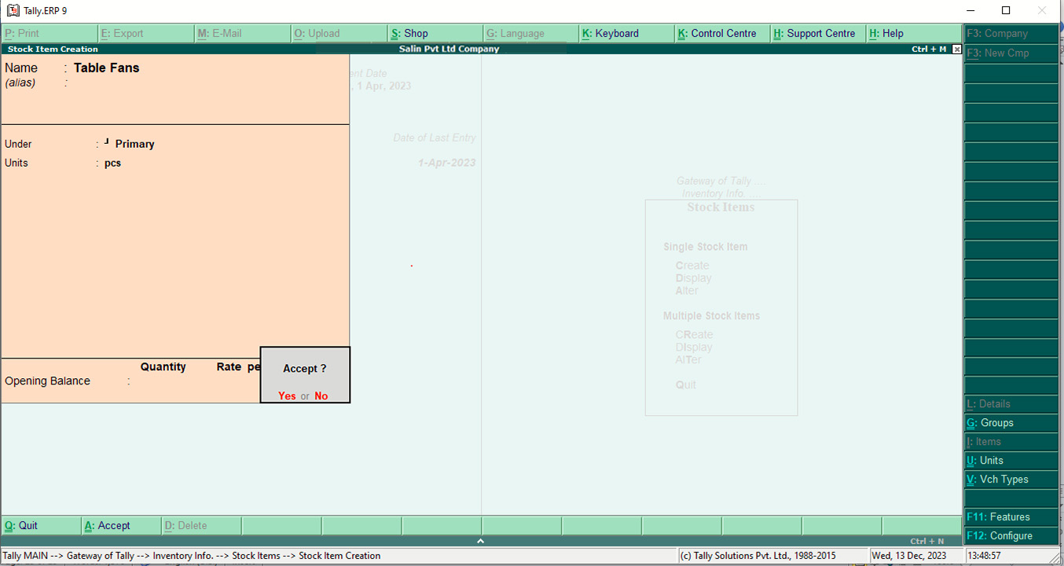

1. **tables**

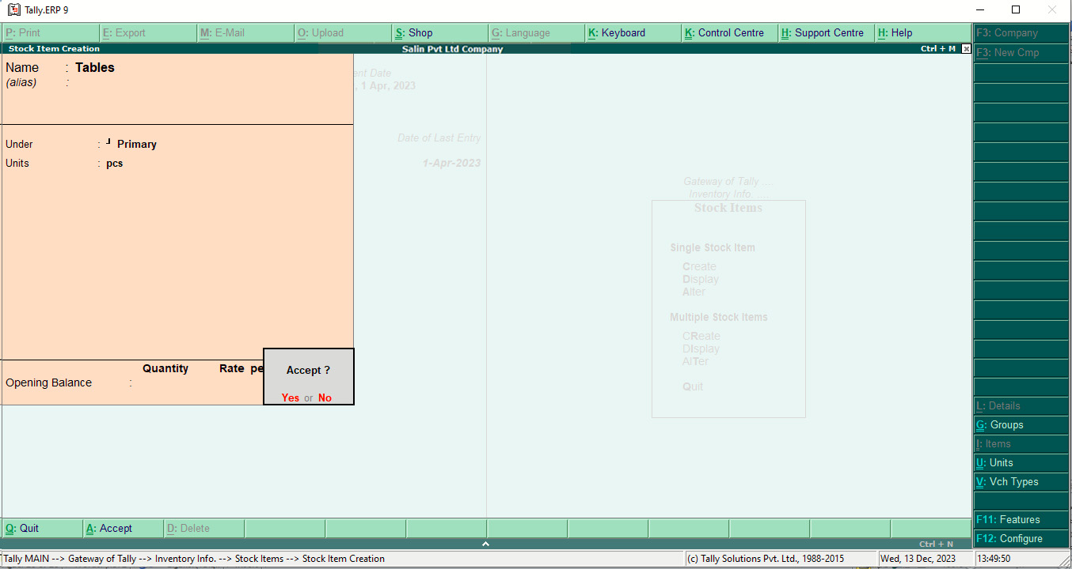

1. **Dell**

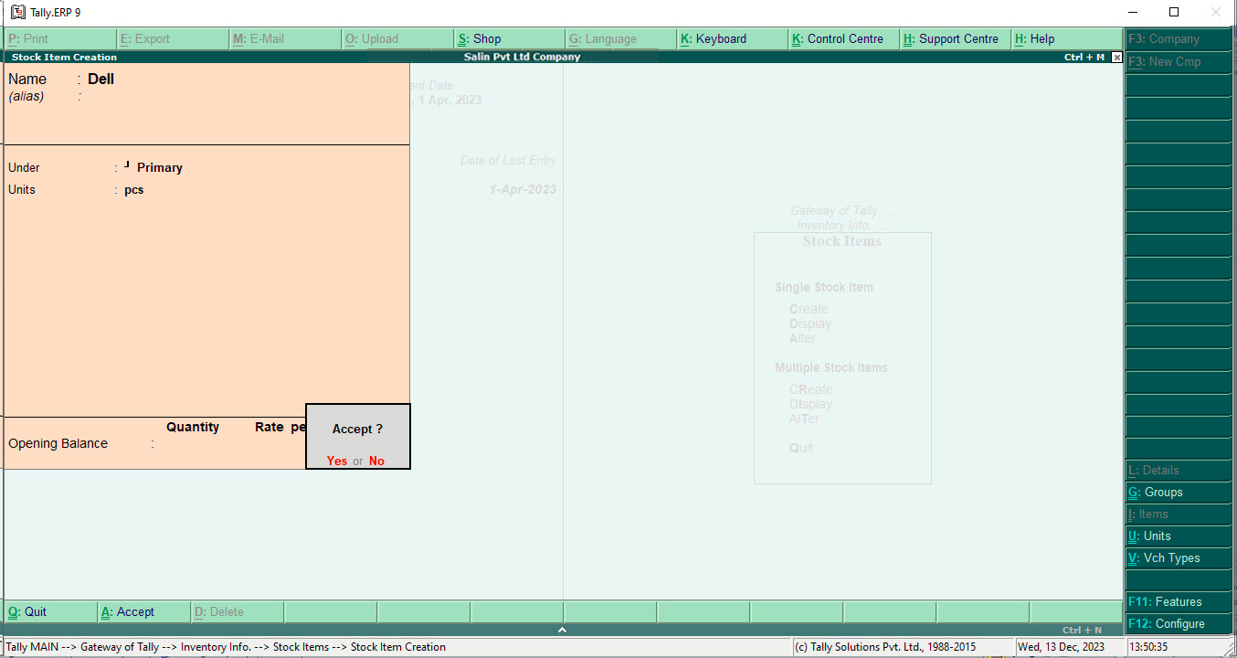

1. **Samsung**

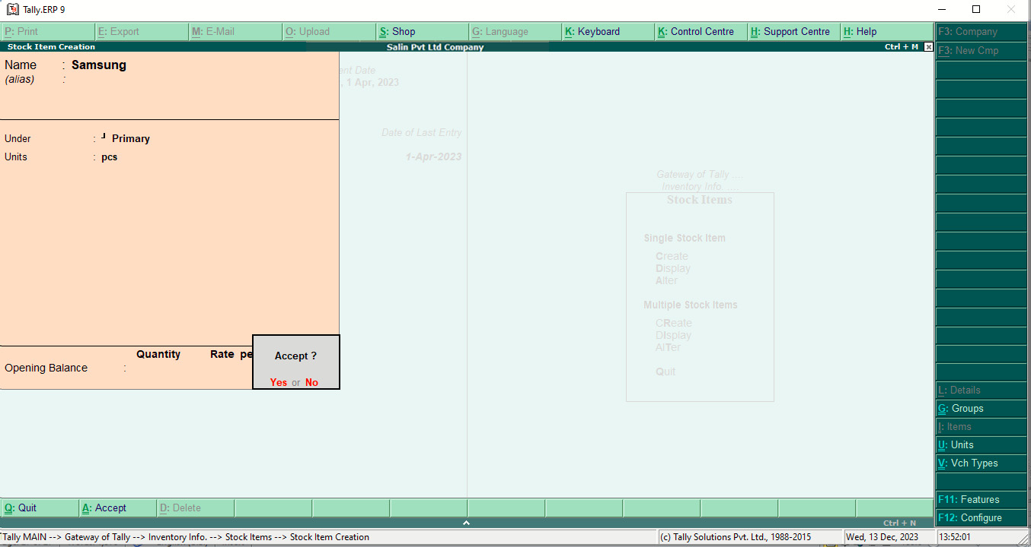

1. **Lenovo**

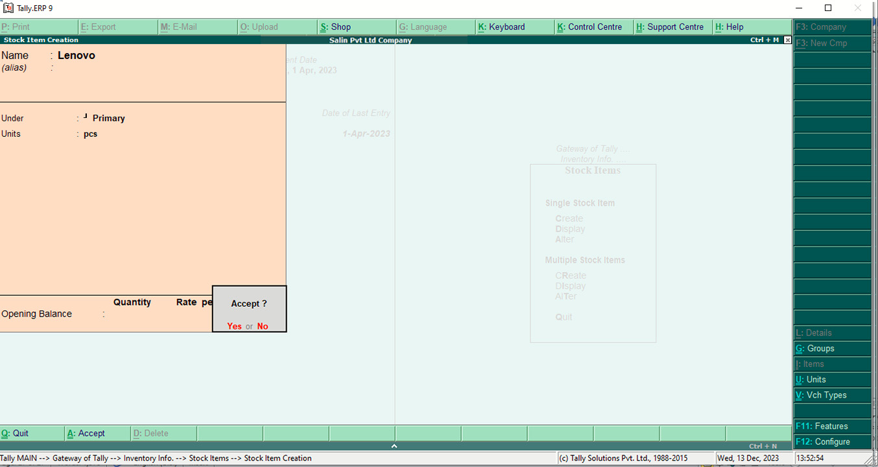

1. **Party Name**
2. **Pashupati & Co.**

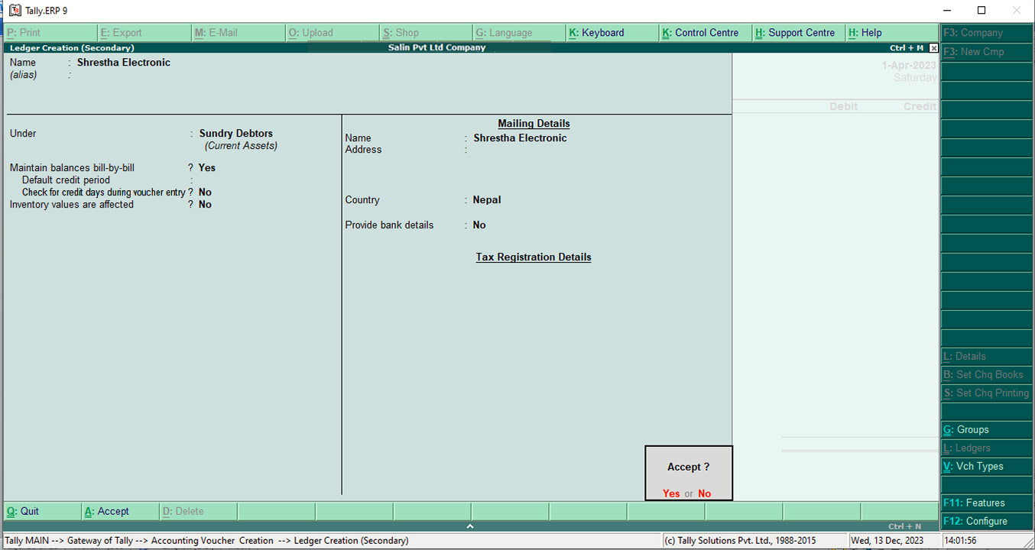

1. **Shrestha Electronics**



1. **Recording**

**Feb 1: Purchased from Pashupati & co.**

100 Economics books @ Rs. 300 each.

50 Accountancy books @ Rs. 700 each.

200 English Books @ Rs. 300

50 Pressure cookers @ Rs. 500 each

100 table fans @ Rs. 1,000 each

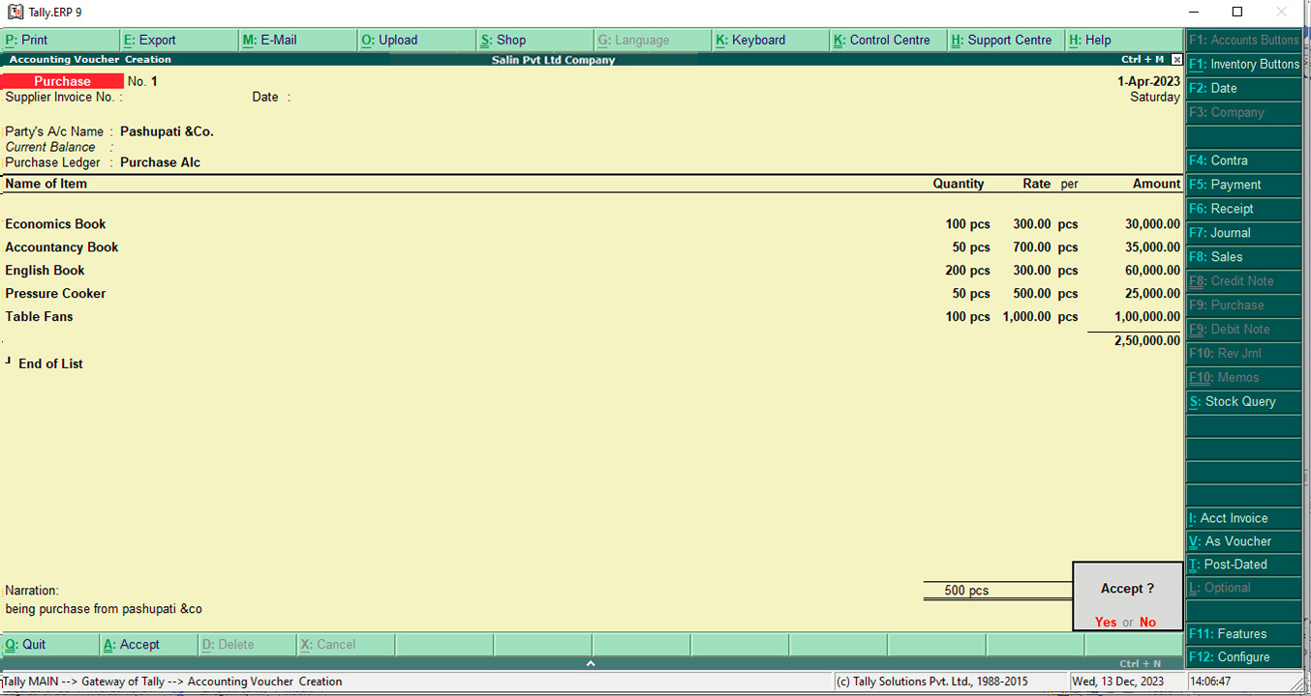

**Feb 3: Purchased on cash.**

20 tables @ Rs. 1,000 each

20 Dell @ Rs. 30,000 each

2 Samsung @ Rs. 120,000 each

5 lenevo @Rs.100,000 each

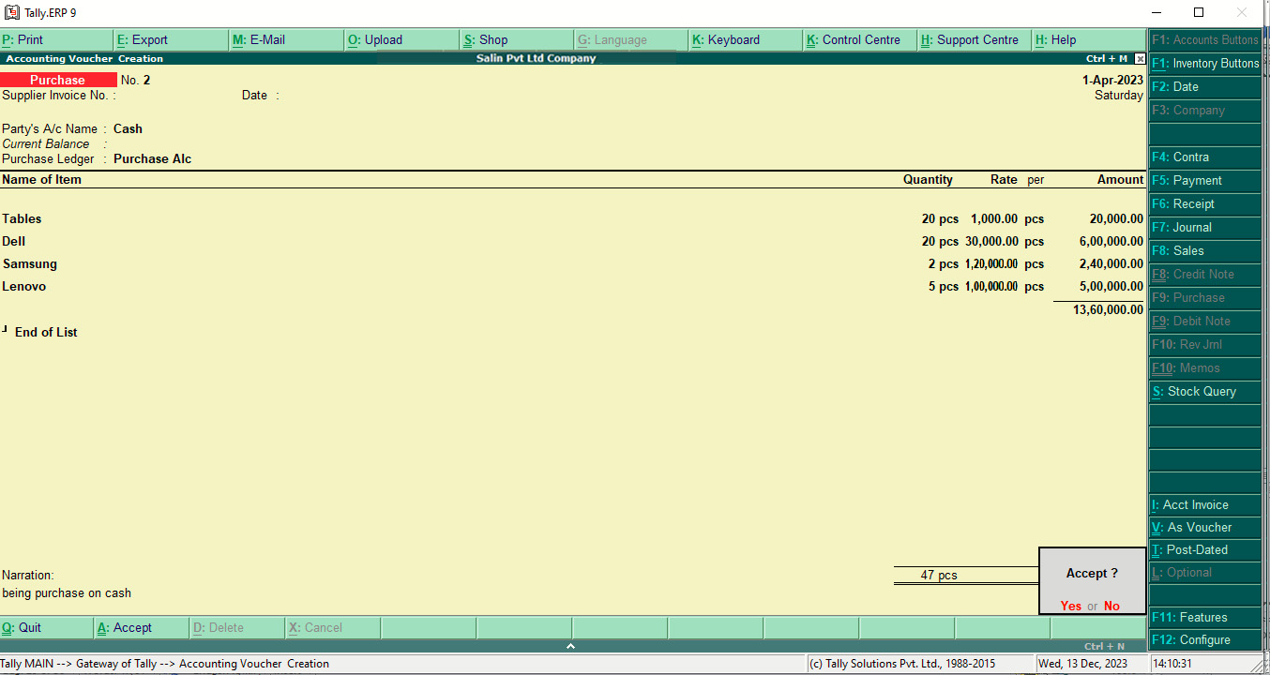

**Feb 7: Sold laptops to Shrestha electronics, on credit.**

15 Dell @ Rs. 35,000 each

4 Lenovo @ Rs. 90,000 each

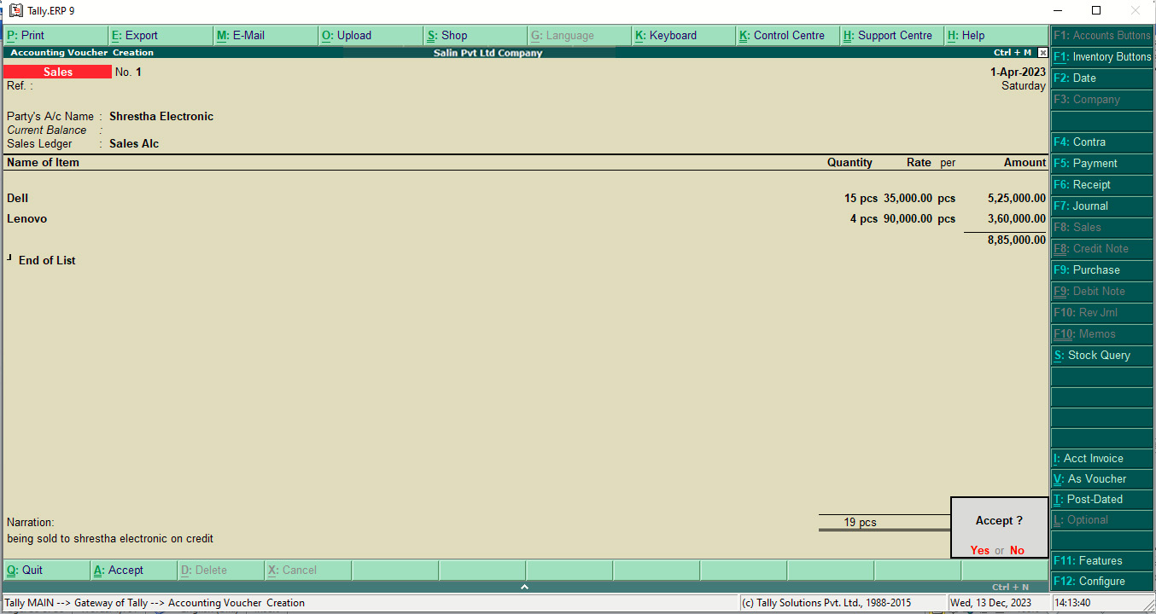

**Feb 9: Sold on cash**

40 Economics books @ Rs. 325 each

15 Pressure cookers @ Rs. 550 each

12 tables @ Rs. 1,275 each

45 Accountancy books @ Rs. 720 each.

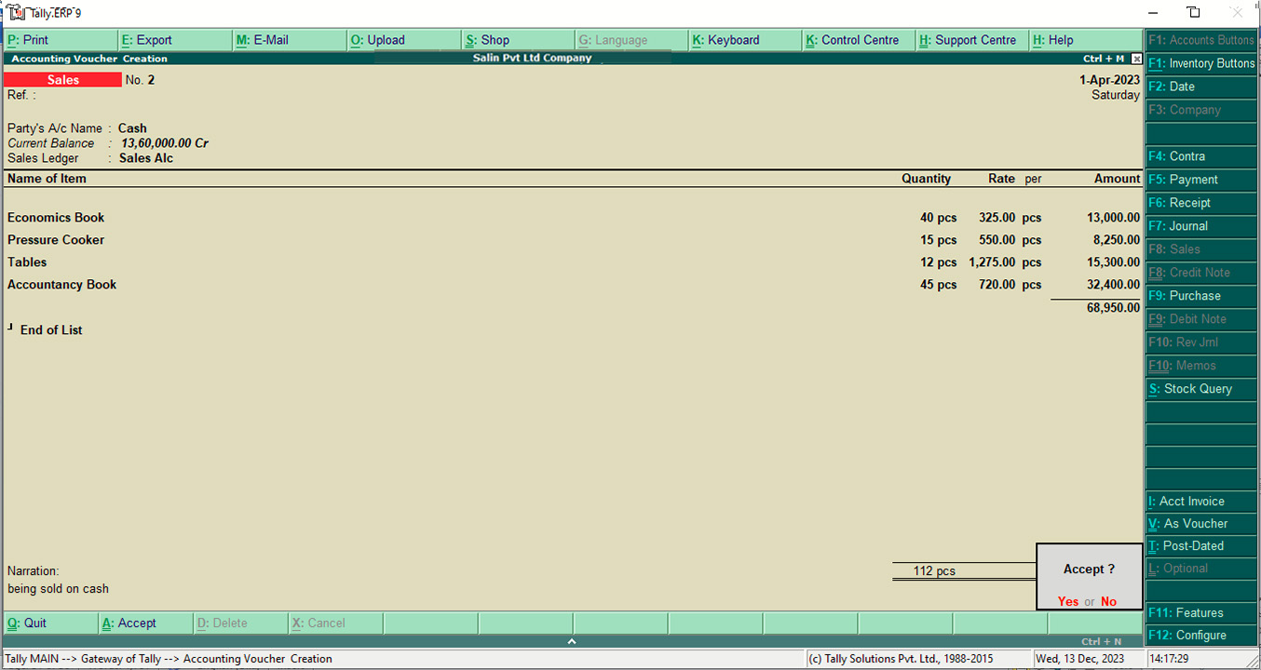

1. **Stock Query**
2. **Accountancy Book**

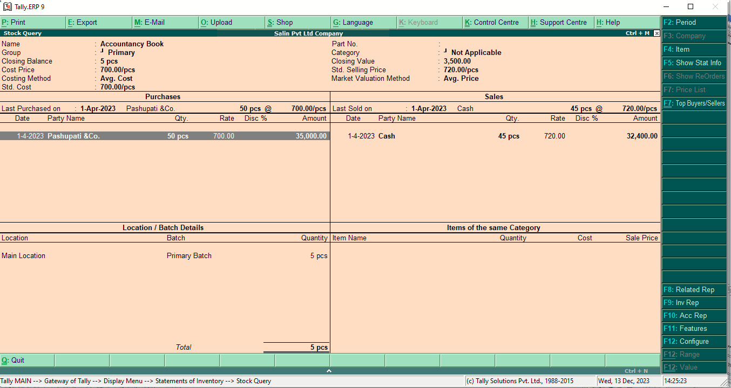

1. **Economics Book**

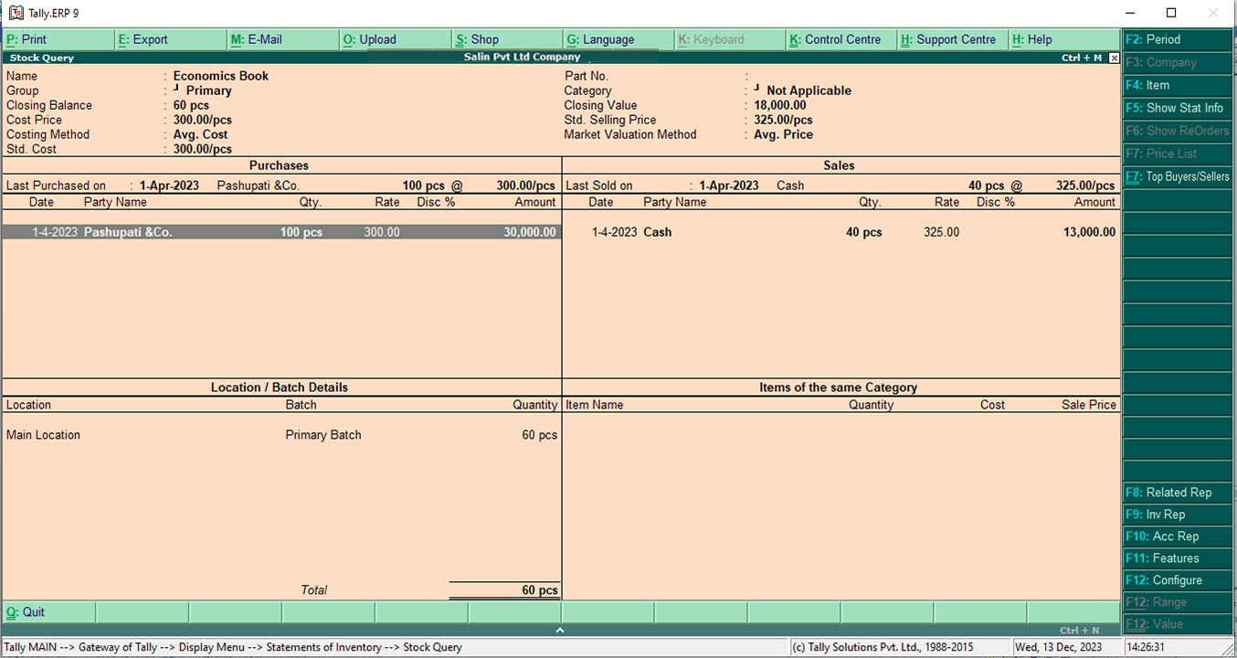

1. **English Book**

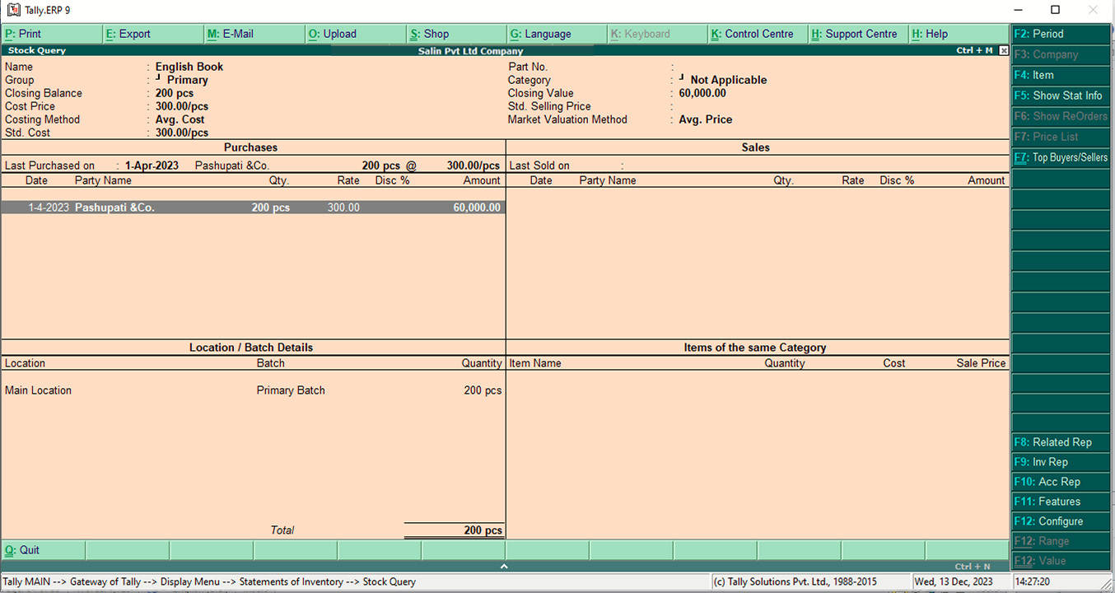

1. **Pressure Cookers**

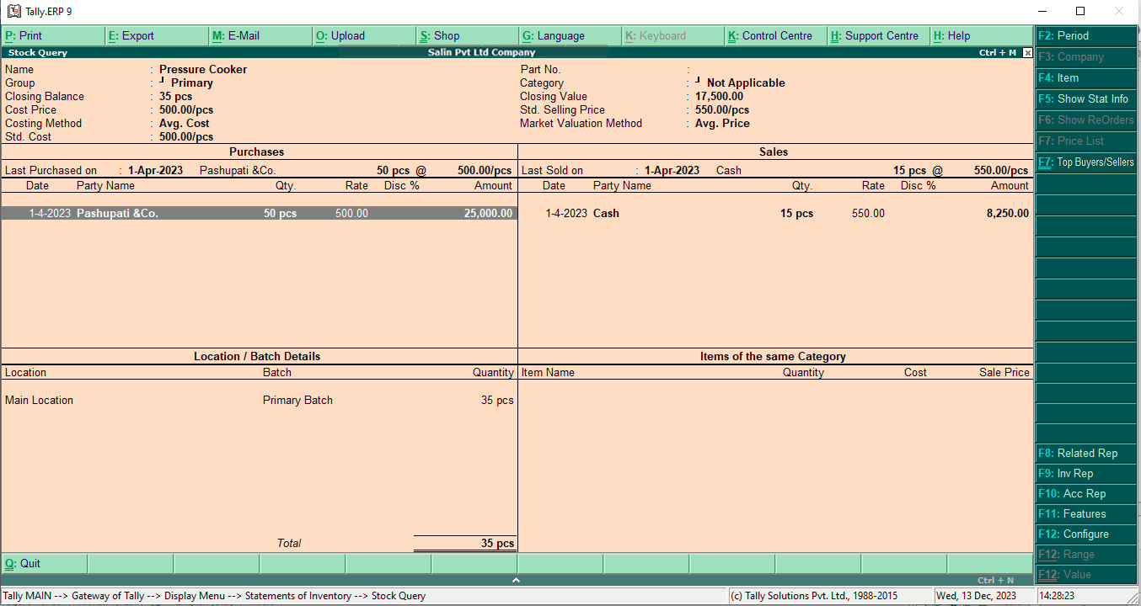

1. **Table Fans**

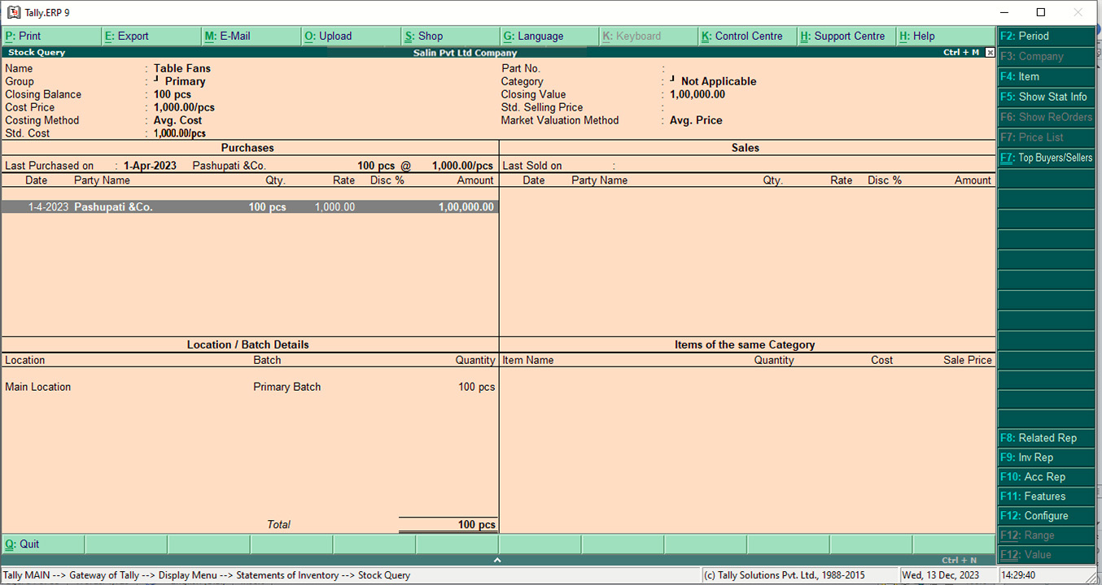

1. **Table**



1. **Dell**

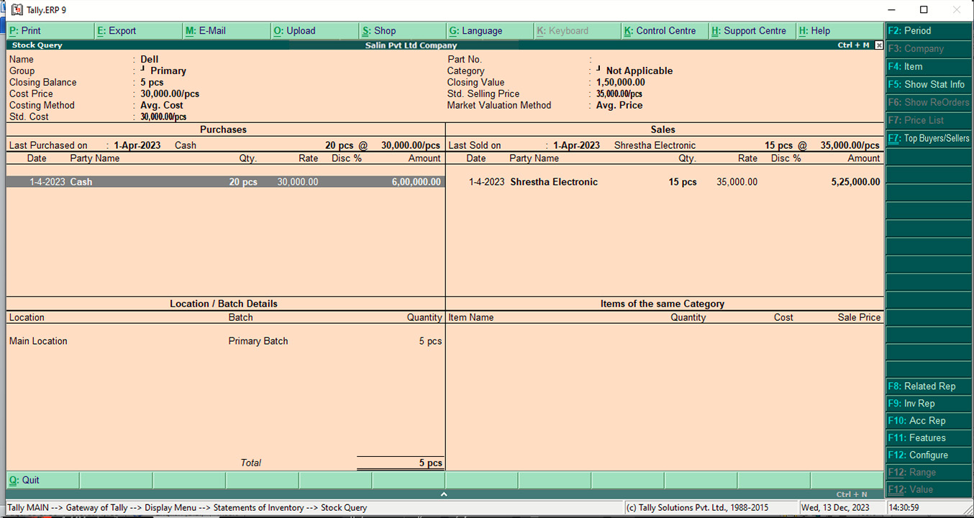

1. **Samsung**

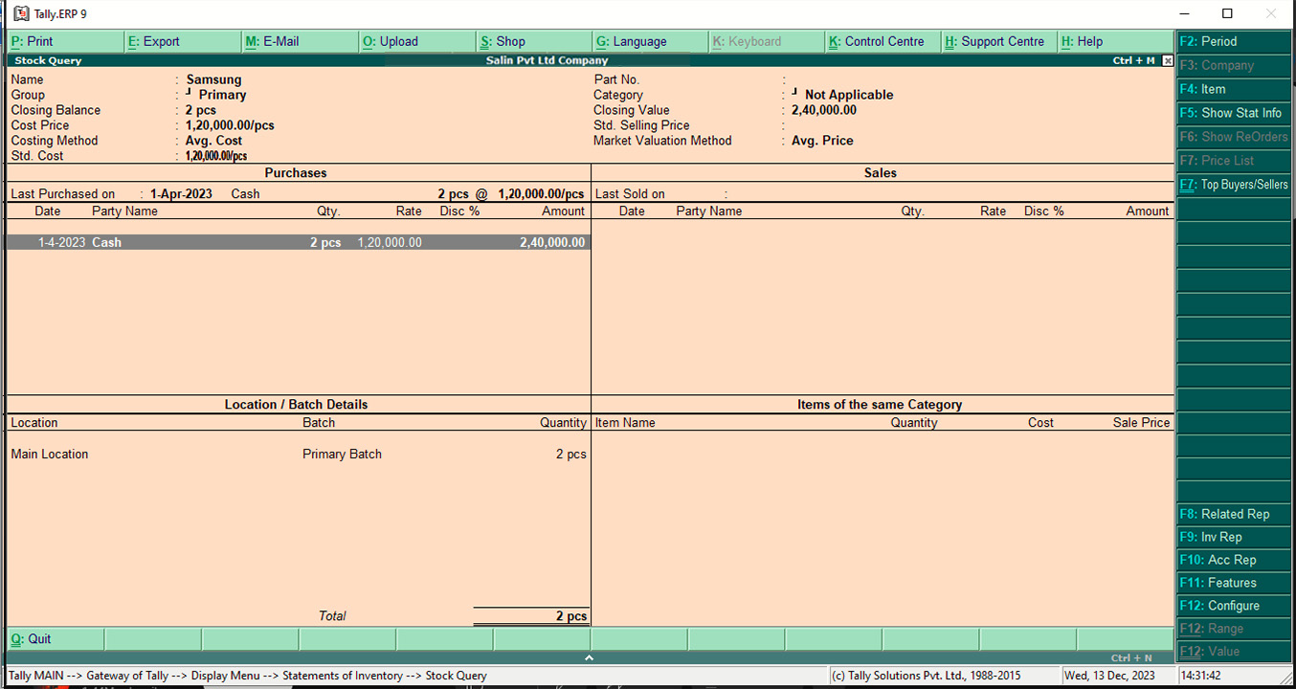

1. **Lenovo**

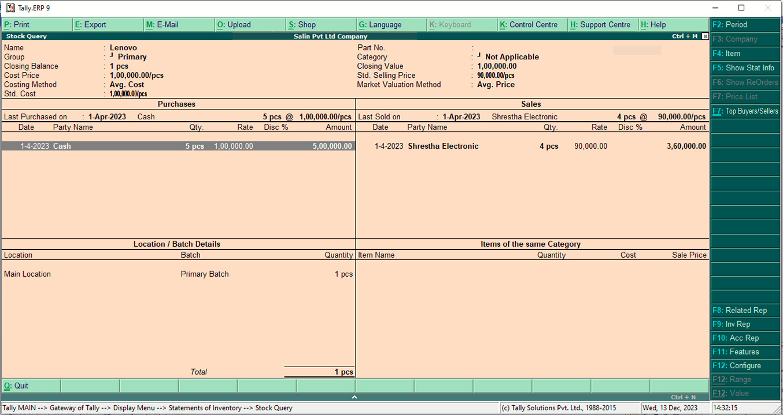

1. **Trial Balance**

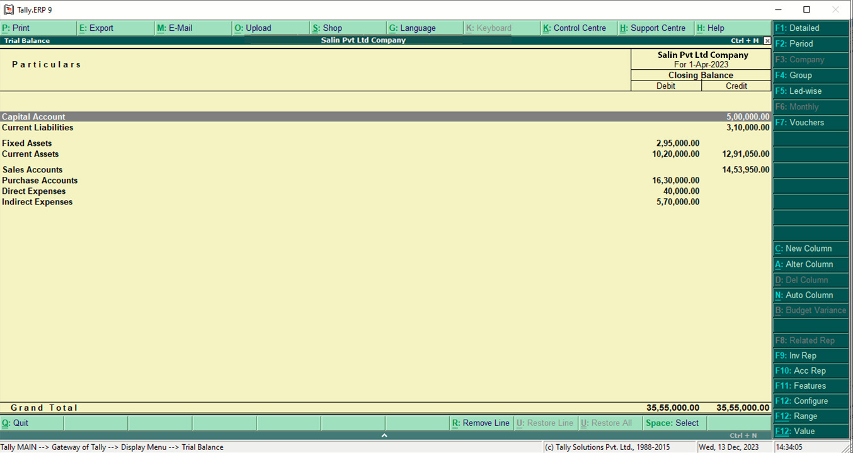

1. **Trading and profit and loss A/c**

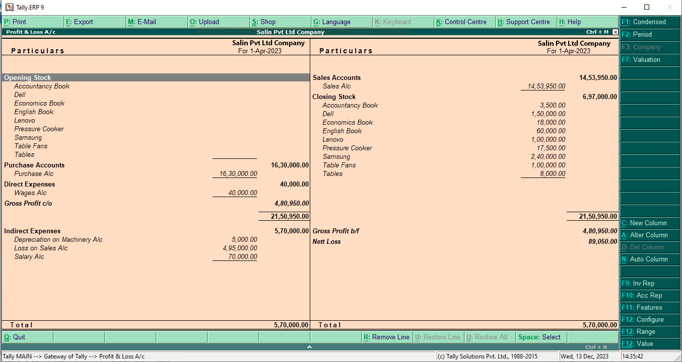

1. **Balance Sheet**

